

EAA/EHCP

Standardised scores

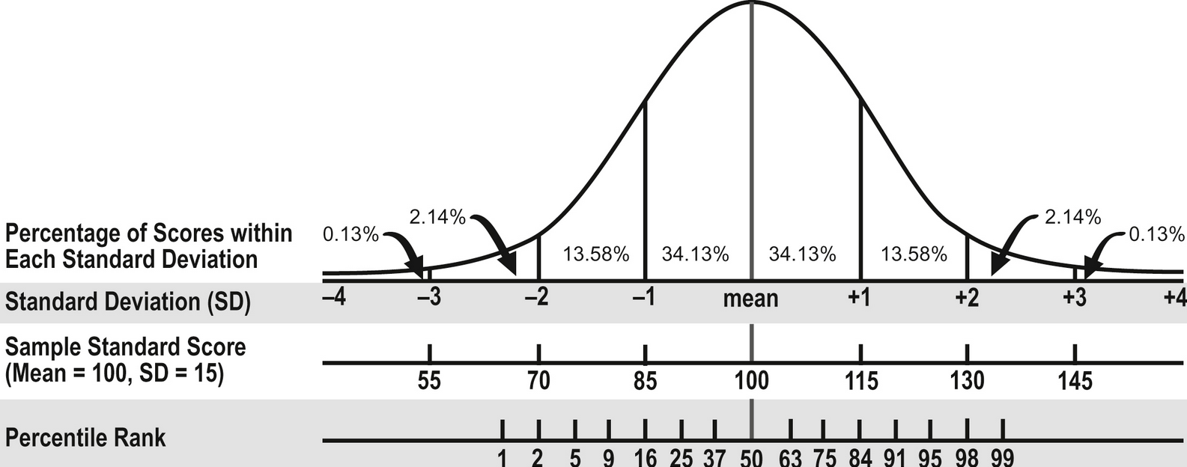

GCSE Grades

G

1

F E

2

D

3

C

4

B

5 6

A

7

A\*

8 9