Trochanteric Bursitis

Summary
It is usually caused by stresses at muscle insertions on the greater trochanter leading to inflammation. This micro trauma results in degenerative changes of tendons, muscles or fibrous tissues.
Conditions associated with trochanteric bursitis include osteoarthritis of the hips, lower back or knees, degenerative disc disease of the lumbar spine, obesity and fibromyalgia.

Symptoms
Trochanteric bursitis typically presents with pain and reproducible tenderness in the region of the greater trochanter, buttock or lateral thigh. Many people find it is a deep pain, which may be aching or burning. The pain may increase over time and it may last for months, even years.
The pain is often more intense when getting up from a low seat, or with exercise and climbing the stairs. Occasionally, patients experience numbness in the upper thigh.
Some patients may present with a limp. It can also be associated with sciatica.

Strategies
- Patients should be recommended to rest and also to decrease their activity.
- Applying an ice pack for 10-20 minutes several times a day may improve symptoms.
- NSAIDs (aspirin, ibuprofen etc) may help to reduce the pain and swelling.

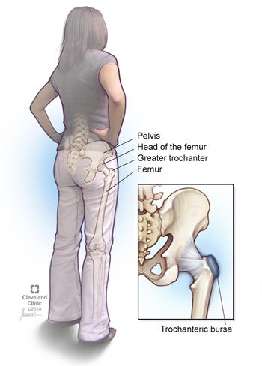
Notes: A trochanter is a tubercle of the femur near its joint with the hip bone. (See diagram)

